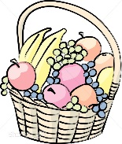Friendship Fruit Salad

During the month of November, our students are learning about the Thanksgiving holiday. It is a great time of year to teach our students about “giving to, sharing with and helping” others. On November 20th, our students will have the opportunity to help us create a “Friendship Fruit Salad” during class time and enjoy for a special snack. We are asking each child to donate 1 can of fruit or 1 fresh fruit item. Please send your donation to school with your child any time before November 20th.

Thank you for your support!

Mrs. Meyer & Mrs. Markle

