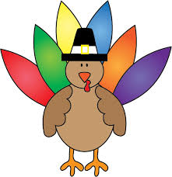November Take Home Project

Every month, we will be sending home a project for the families to complete together. Your goal is to complete the project and hand it back in to the teacher before the end of the month. Your family will receive 1 volunteer hour for participating. All projects will be hung or displayed in our classroom!
We are asking families to please use the paper provided to write down your child’s favorite recipe. We want to know how your child “thinks” their favorite food is baked. We want to know their responses…even if they are completely goofy! Our goal is to make a Classroom Recipe Book.

Good luck and have fun!
Mrs. Meyer & Mrs. Markle

My Favorite Food Recipe

Child’s Name: _________________________________________
Recipe for making: ___________________________________

How many does it serve? ________________________

Ingredients Needed: __________________________________________________________________________________________________________________________________________________________________________________________________________________________________________________________________________________________________

How hot does the oven need to be? _____________________
How long does it cook for? ____________________________

Step by Step Directions:
______________________________________________________________________________________________________________________________________________________________________________________________________________________________________________________________________________________________

