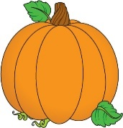 October Take Home Project 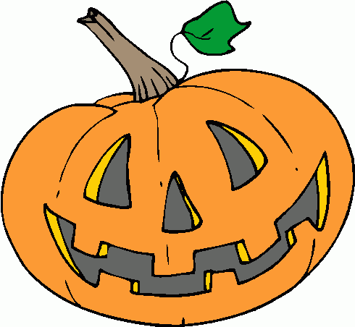

Every month, we will be sending home a project for the families to complete together. Your goal is to complete the project and hand it back in to the teacher before the end of the month. Your family will receive 1 volunteer hour for participating. All projects will be hung or displayed in our classroom!
For the month of October, we are asking each family to create a pumpkin or jack-o-lantern. Be creative! You may use paper, paints, cardboard, foam, wood, stickers, noodles, glitter, sequins, markers, clay, etc. Use whatever you have available at home! Each project must be able to fit in your child’s backpack. Projects are due by October 19th!

Good luck and have fun!
Mrs. Meyer & Mrs. Markle

