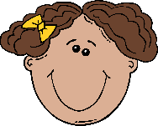September Take Home Project

This month, we are learning about the topic “All about Me.” For 1 volunteer point, we are asking families to work together and create your child’s face. Talk with your child about their facial features (eye color, eye brows, nose, lip color, hair color, freckles, etc.) Use the construction paper provided. Use any materials that you have at home (markers, crayons, noodles, stickers, glitter, googly eyes, etc.) Be creative! All projects are due by September 21st. We will display finished projects in our classroom.

Have fun!
Mrs. Meyer & Mrs. Markle

